Preparing a paper using microsoft word for publication in JN
JOHN DOE^{1*}, JANE DOE², MICHAEL DOE¹

¹Faculty of Medicine, University of Indonesia, Depok, Indonesia
²Faculty of Medicine, Universitas Syiah Kuala, Banda Aceh, Indonesia
Abstract. All articles must contain an abstract. The abstract text should be formatted using 9-point Times (or Times Roman, or Times New Roman) and justify. Leave space after the abstract before you begin the main text of your article. The text of your article should start on the same page as the abstract. The abstract follows the addresses and should give readers concise information about the content of the article and indicate the main results obtained and conclusions drawn. As the abstract is not part of the text it should be complete in itself; no table numbers, figure numbers, references or displayed mathematical expressions should be included. It should be suitable for direct inclusion in abstracting services and should not normally exceed 200 words. The abstract should generally be restricted to a single paragraph. Since contemporary information-retrieval systems rely heavily on the content of titles and abstracts to identify relevant articles in literature searches, great care should be taken in constructing both
Keywords: one, one two, one three, one four, one five

INTRODUCTION
These guidelines, written in the style of a submission to journal Natural., discuss how to prepare your paper using Microsoft Word. In addition to the usual guidance on style/formatting, there are notes and links to assist in using some of Word’s features such as inserting graphics, formatting equations and so forth [1,2,3]. A Word template is available for download from the jurnal natural website. Follow the ‘Guidelines for authors’ link on http://www.jurnal.unsyiah.ac.id/natural/issue/view/712 [4].
Explaining the background, problems, importance of research, brief literature review that relates directly to research or previous findings that need to be developed and ended with a paragraph of research purposes. A balance must be kept between the pure and applied aspects of the subject [4]. Explaining the background, problems, importance of research, brief literature review that relates directly to research or previous findings that need to be developed and ended with a paragraph of research purposes. A balance must be kept between the pure and applied aspects of the subject.
Explaining the background, problems, importance of research, brief literature review that relates directly to research or previous findings that need to be developed and ended with a paragraph of research purposes. A balance must be kept between the pure and applied aspects of the subject [4]. Explaining the background, problems, importance of research, brief literature review that relates directly to research or previous findings that need to be developed and ended with a paragraph of research purposes. A balance must be kept between the pure and applied aspects of the subject.

METHODOLOGY
Submethod1
Make sure that work can be repeated according to the details provided. It contains technical information of the study presented clearly. Therefore, readers can conduct research based on the techniques presented. Materials and equipment specifications are necessary. Approaches or procedures of study together with data analysis methods must be presented.
Submethod2
Make sure that work can be repeated according to the details provided. It contains technical information of the study presented clearly.
RESULTS AND DISCUSSION
Subresult1
Well-prepared tables and or figures must be of significant feature of this section, because they convey the major observations to readers. Any information provided in tables and figures should no longer be repeated in the text, but the text should focus on the importance of the principal findings of the study. In general, journal papers will contain three-seven figures and tables. Same data cannot be presented in the form of tables and figures.
The results of the study are discussed to address the problem formulated, objectives and research hypotheses. It is highly suggested that discussion be focused on the why and how of the research findings can happen and to extend to which the research findings can be applied to other relevant problems.
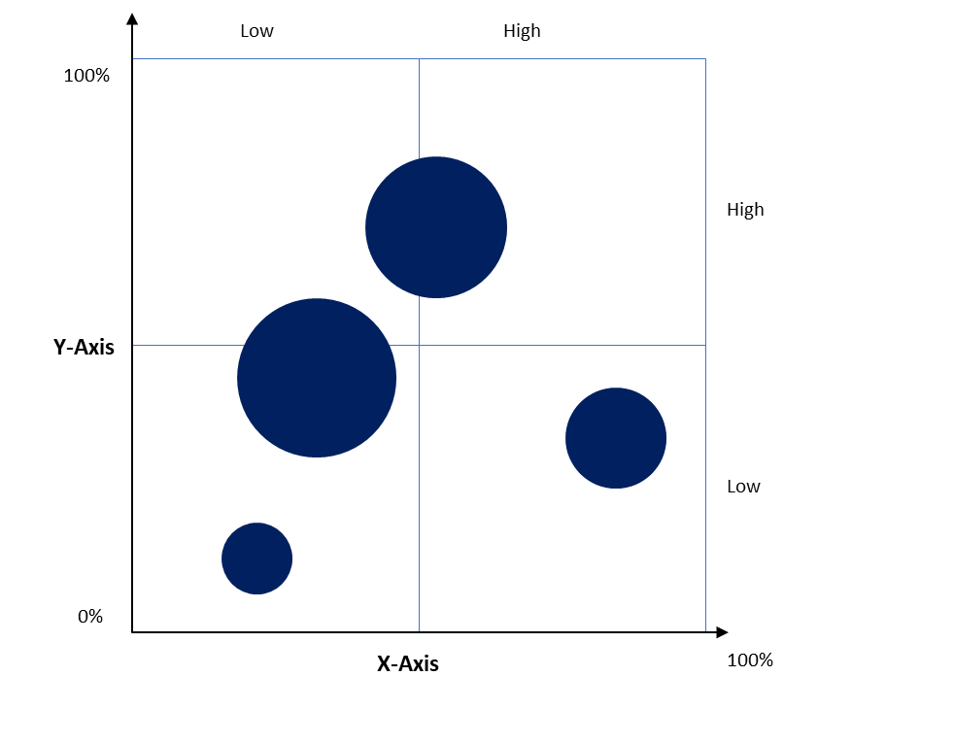
Figure 1. The mean of body weight of different groups during study period.

Subresult2
Well-prepared tables and or figures must be of significant feature of this section, because they convey the major observations to readers. Any information provided in tables and figures should no longer be repeated in the text, but the text should focus on the importance of the principal findings of the study [5]. In general, journal papers will contain three-seven figures and tables. Same data cannot be presented in the form of tables and figures.
The results of the study are discussed to address the problem formulated, objectives and research hypotheses. It is highly suggested that discussion be focused on the why and how of the research findings can happen and to extend to which the research findings can be applied to other relevant problems.
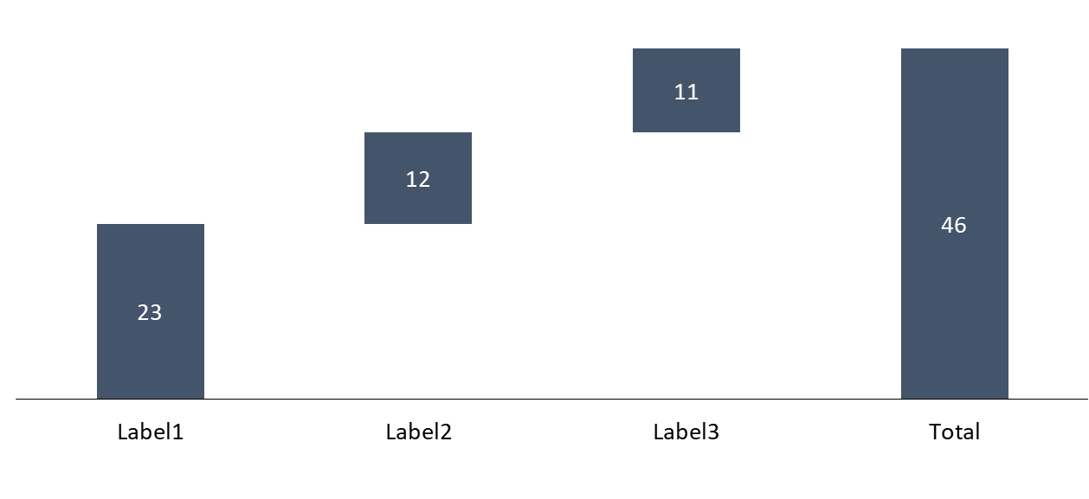
Figure 2. The mean of body weight of different groups during study period.

The results of the study are discussed to address the problem formulated, objectives and research hypotheses [6]. It is highly suggested that discussion be focused on the why and how of the research findings can happen and to extend to which the research findings can be applied to other relevant problems.
The results of the study are discussed to address the problem formulated, objectives and research hypotheses [6]. It is highly suggested that discussion be focused on the why and how of the research findings can happen and to extend to which the research findings can be applied to other relevant problems (Table 1).
Table 1. The value of the sensitivity of the pH optical sensor to variations in the concentration of phosphate buffer

Concentration  (M) | Liniear range (pH) | Sensitivity  (AU/pH Unit) | R2
0.01 | 7.0 - 8.5 | 0.030±0.0090 | 0.994
0.03 | 7.0 - 9.5 | 0.161±0.0003 | 0.925
0.05 | 7.5 -9.5 | 0.139±0.0020 | 0.953
0.075 | 6.5 - 8.0 | 0.367±0.0080 | 0.991
CONCLUSION
Conclusion should be withdrawn on the basis of research findings, formulated concerns and research purposes. Conclusion is presented in one paragraph without numerical form of expression. Explain your research contributions to science.
ACKNOWLEDGMENT

The who are not mentioned as authors should be acknowledged, and their contribution should be described. All sources of funding for the work must be acknowledged, both the research funder and the grant number (if applicable) should be given for each source of funds.

REFERENCE

- Halliwell, B.; Gutteridge, J. 1999 Free radicals in medicine and biology 3rd ed (New York: Oxford University Press)
- Liu, D.; Zhong, T.; Chang, P. R.; Li, K.; Wu, Q. 2010. Starch composites reinforced by bamboo cellulosic crystal. Bioresour. Technol. 101 2529 – 2536.
- Ma, X.; Chang, P.R. and Yu, J. 2008. Properties of biodegradable thermoplastic pea starch/ microcristalline cellulose composite. J. Carbohydr. Polym. 3 369-375.
- Zakir, H.M.; Hasan, M.; Shahriar, S.M.S.; Ara, T.; Hossain M. 2016. Production of biofuel from agricultural plant wastes: corn stover and sugarcane bagasse, Chem. Eng. Sci. 4 (1), 5-11.
- Shukla, S.K.; Nidhi; Sudha;Pooja,N.; Charu; Akshay; Silvi; Manisha; Rizwan; Anand,B.; Dubey,G.C. and Tiwari,A, 2013. Preparation and characterization of cellulose derived from rice husk for drug delivery. Adv. Mat.lett. 4 (9) 714-719.
- Poonsawat, T.; Baydoun, A.; Chomko, S.; Talubmook, C. 2011 Cytotoxicity and bioactivities of extract from Tinospora Crispa Stems. The 12th Graduate Research Conference; Thailand: Khon Koen University; p. 694-701.

